9.65: a) 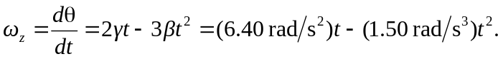
b) 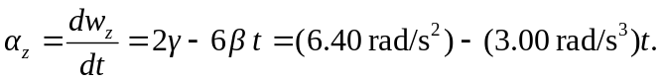

c) An extreme of angular velocity occurs when 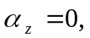which occurs at
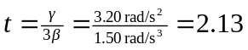 s, and at this time
